|  |  |
| --- | --- |
| Student Name | **Arbab Hussain Qureshi** |
| Roll Number | **22SW028** |
| Section | **01** |

**DBS LAB # 04 – SELECT Statement Queries**

**Tasks:**

**Write 10 Select Statements with Outputs.**

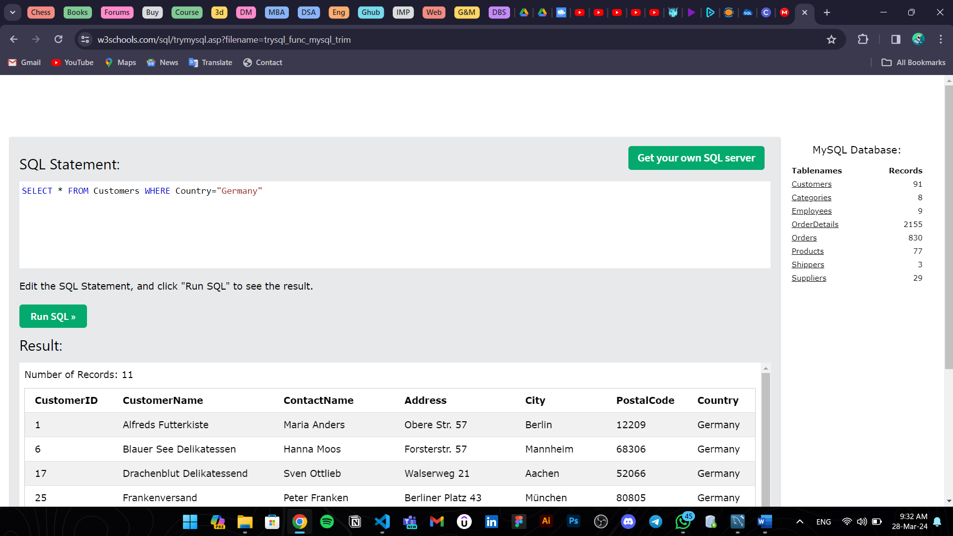1. Retrieve info of all customers who belongs to Germany.

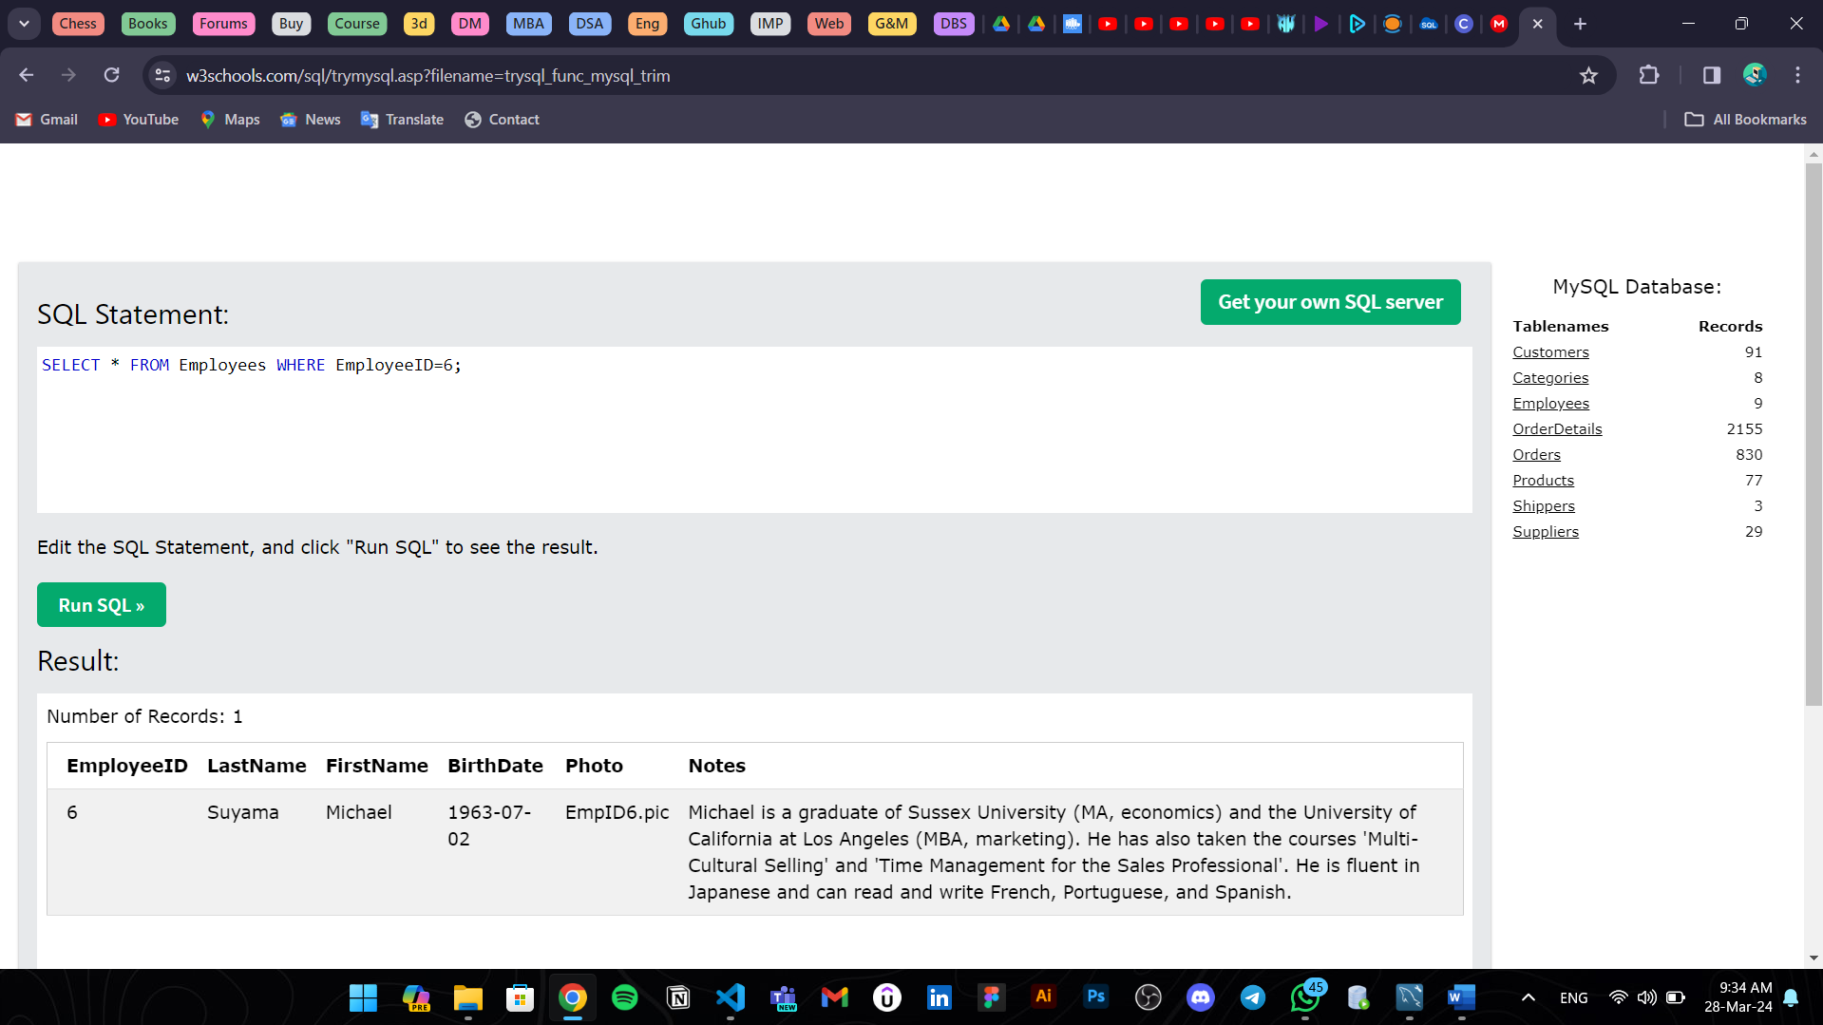2. Retrieve info of employee who has idNo 06.

3. Retrieve info of Customers whose name belongs with A.

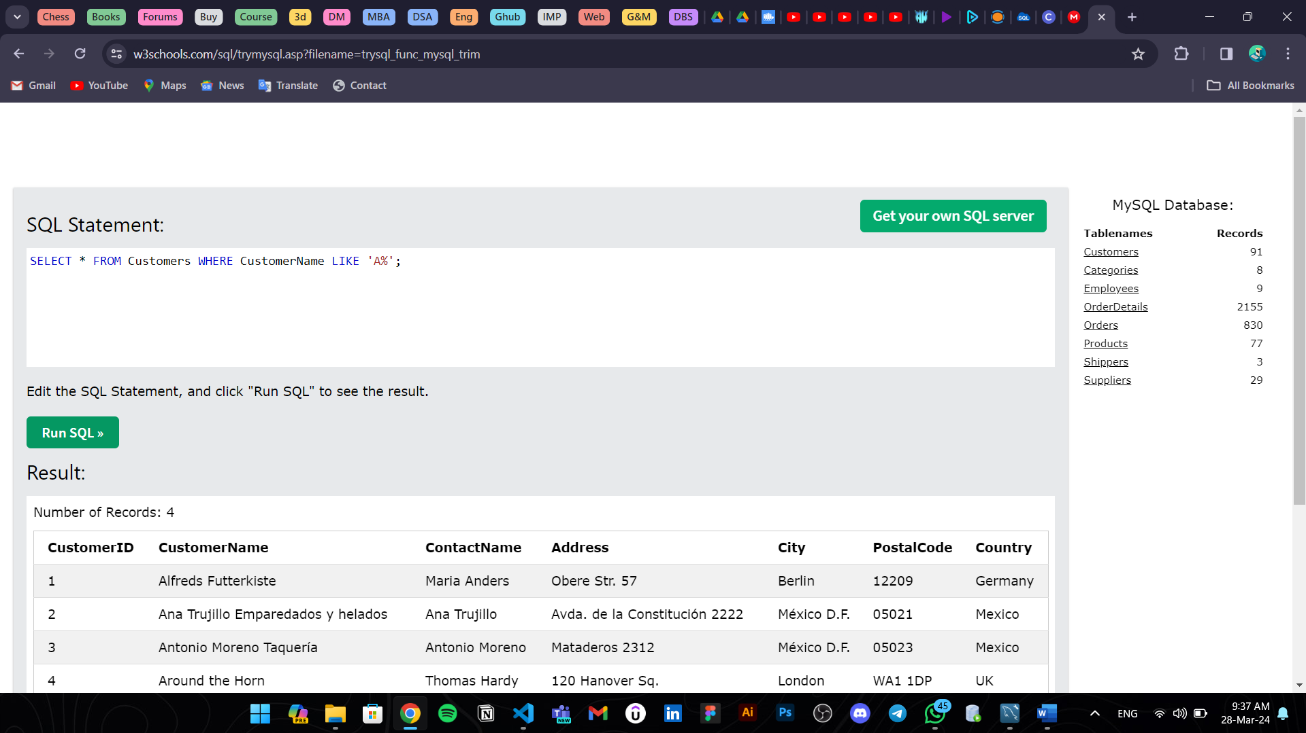

4. Retrieve Employees born after 1960.

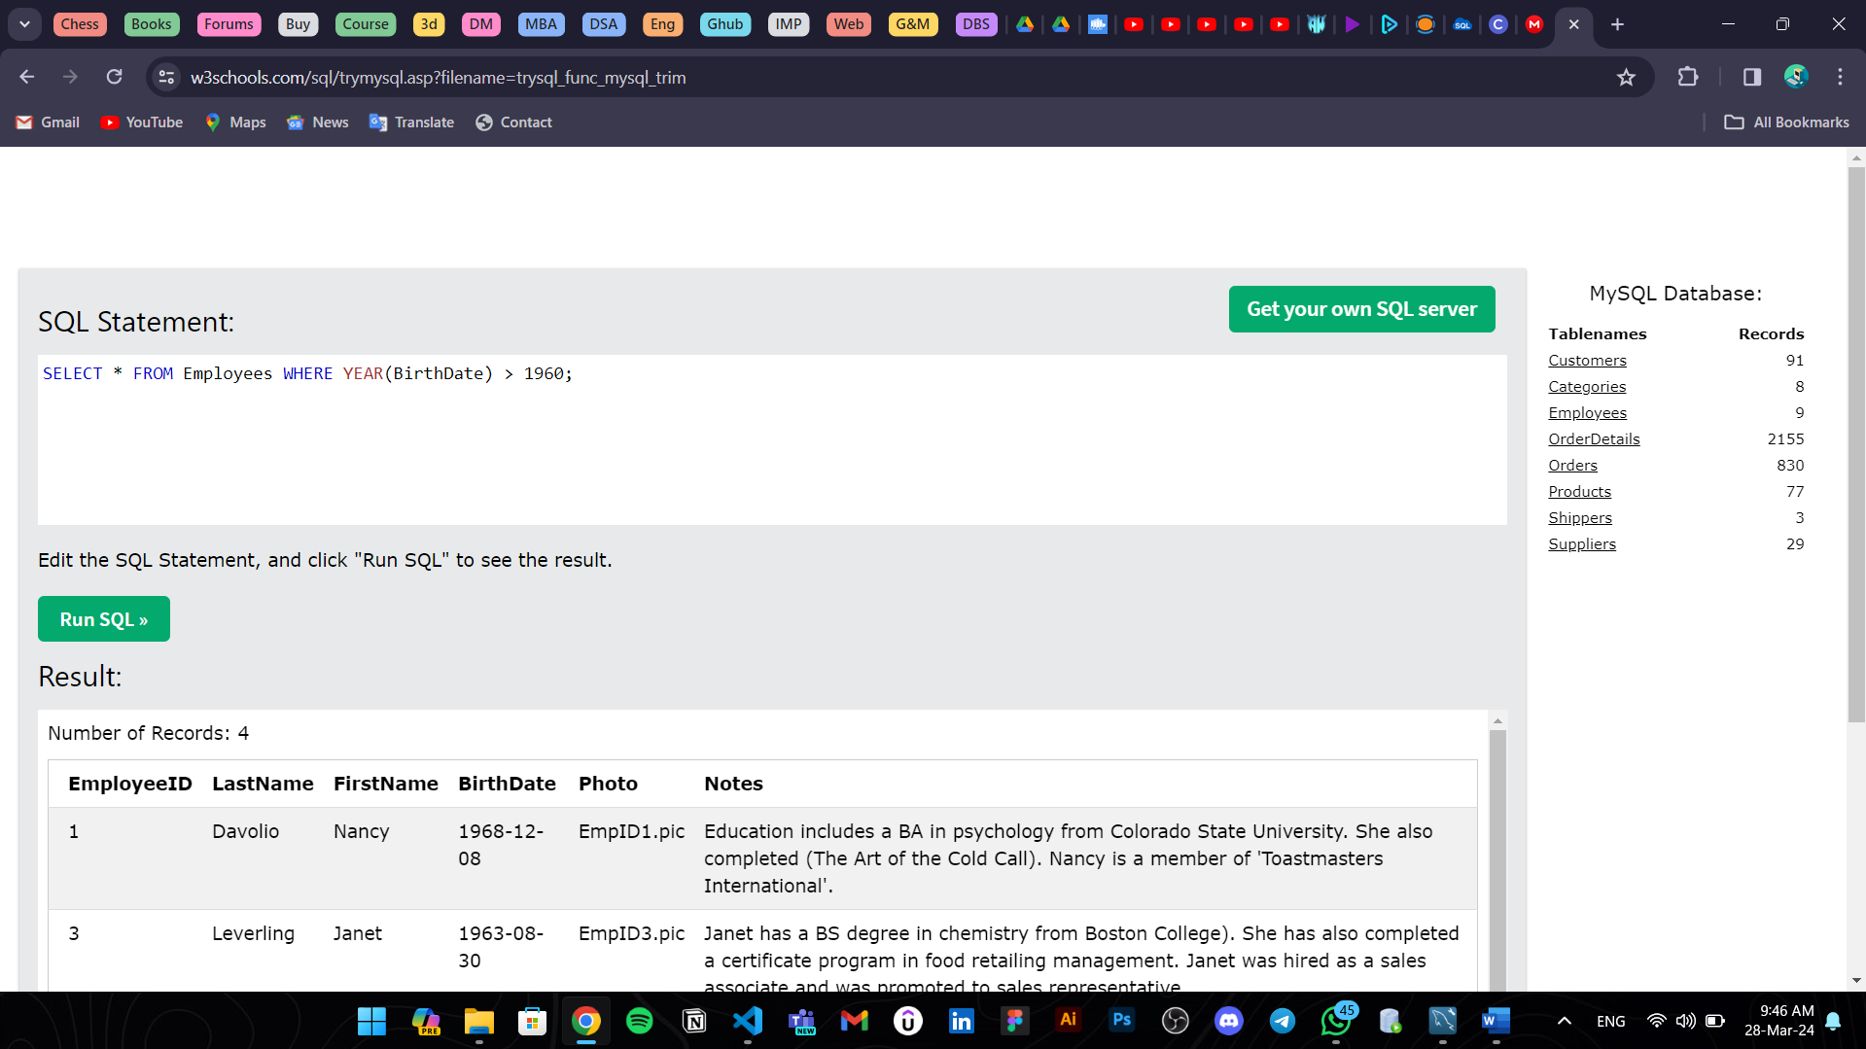

5. Find products whose price is less than 20.

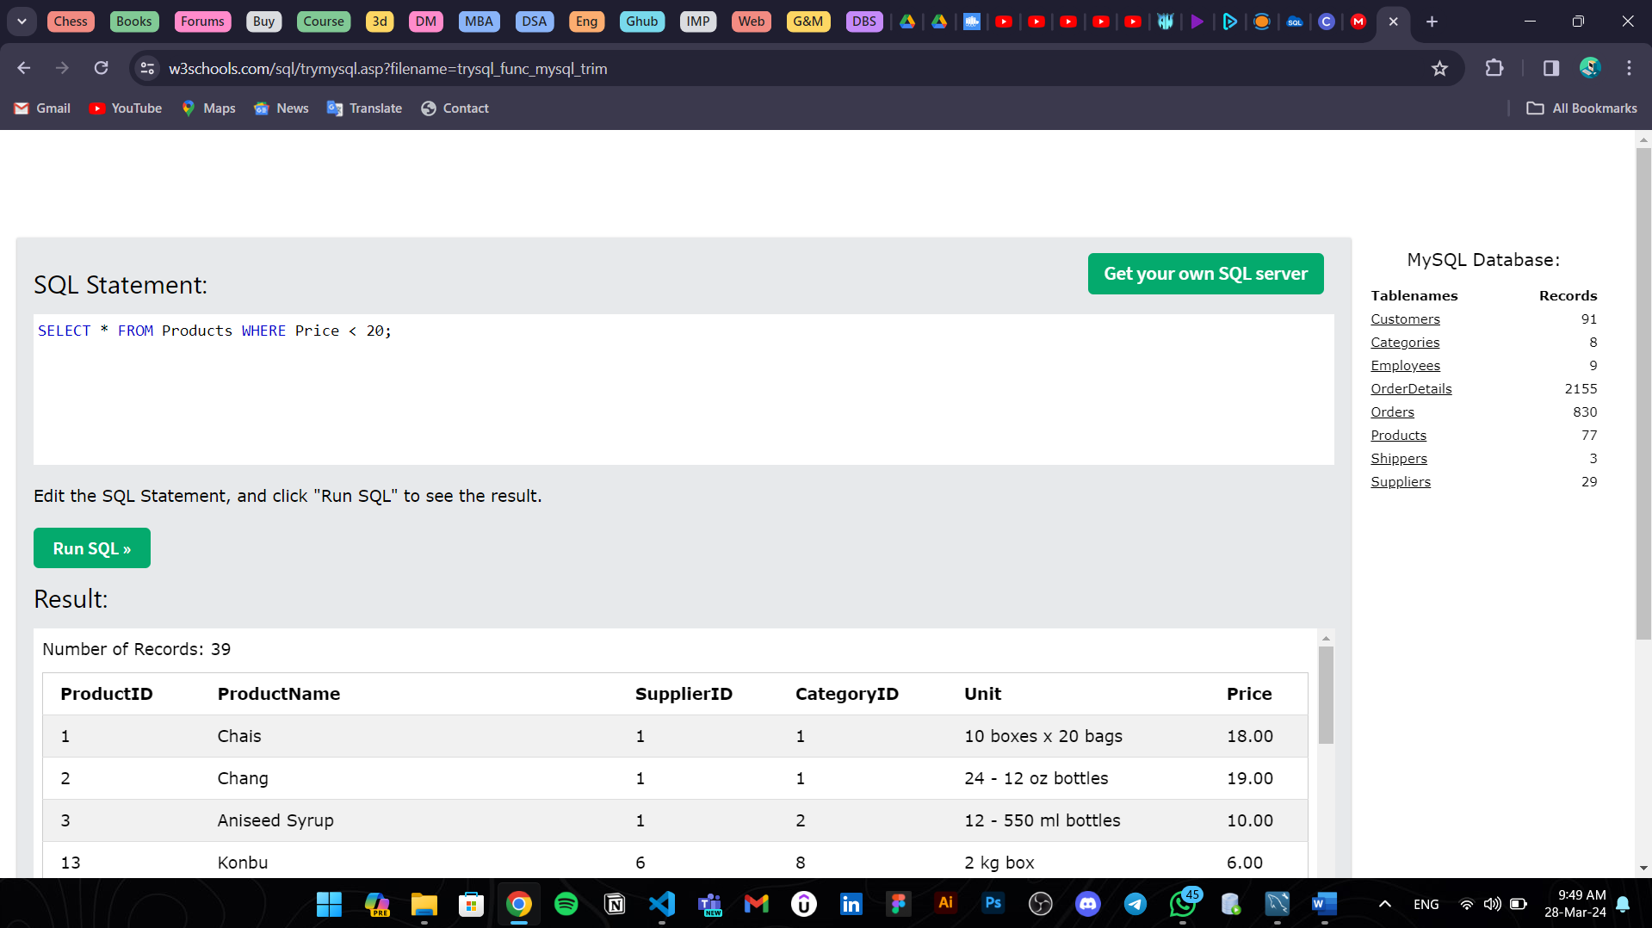

6. Retrieve customers whose name’s second letter is ‘e’:

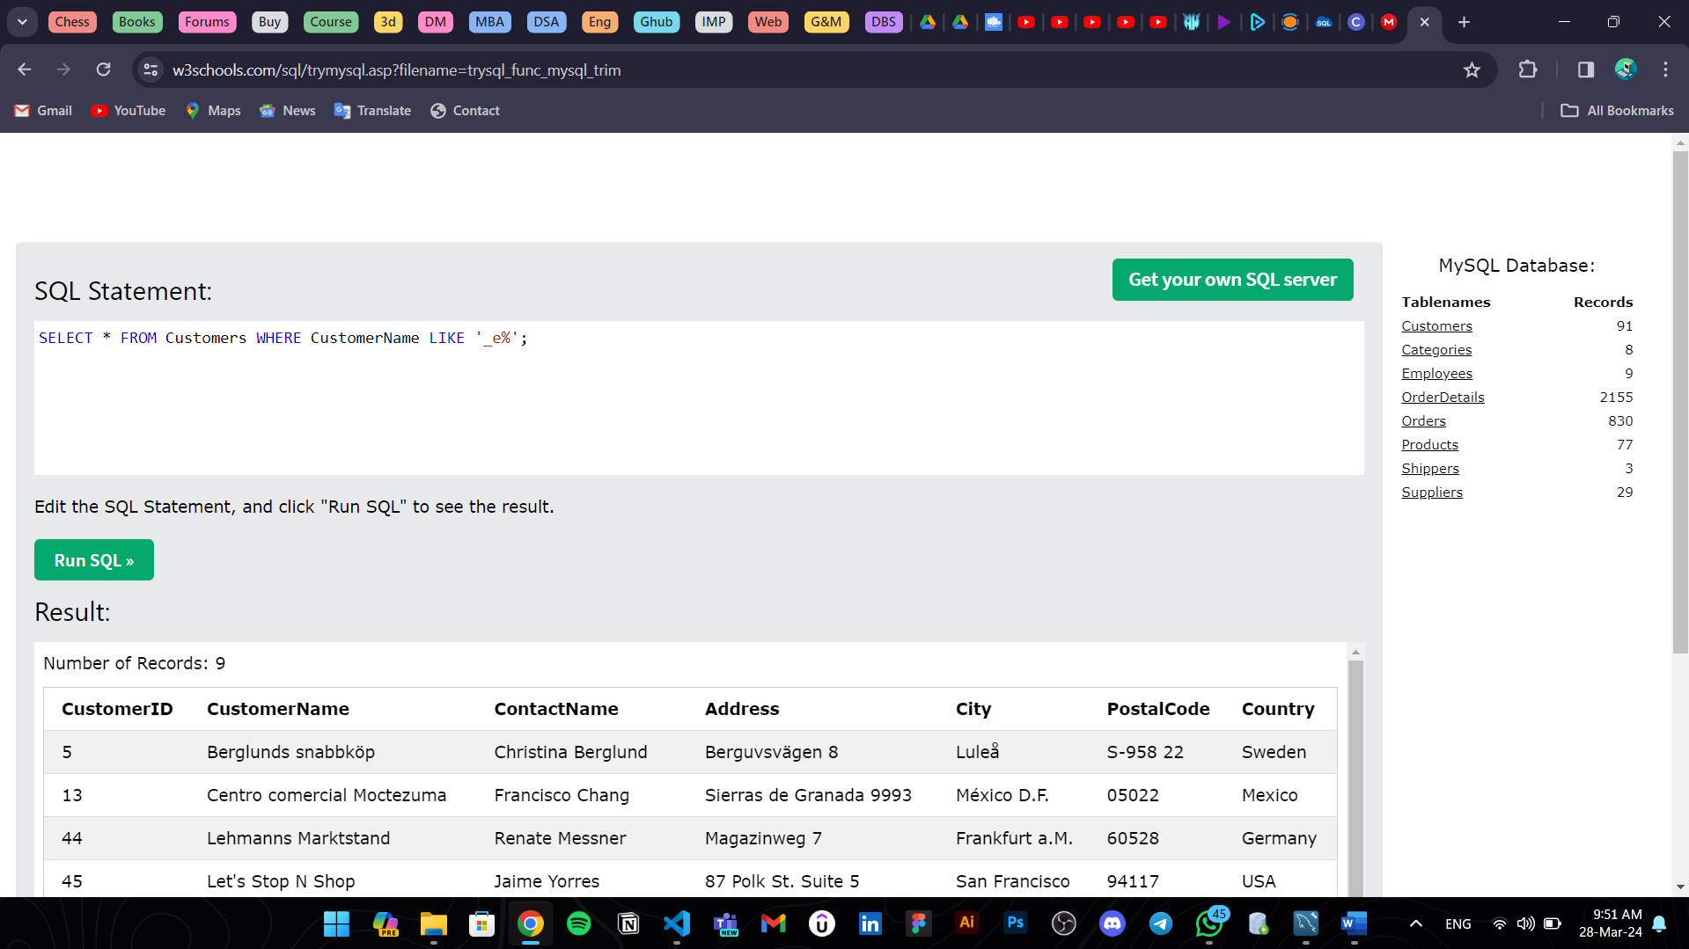

7. Retrieve suppliers from countries with postal codes starting with '5'

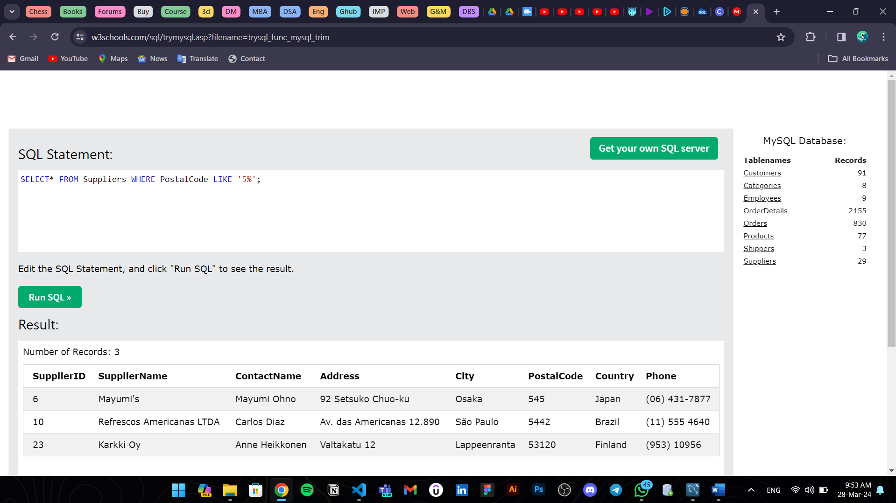

8.Retrieve suppliers whose contact names start with 'N' and are from countries other than Germany.

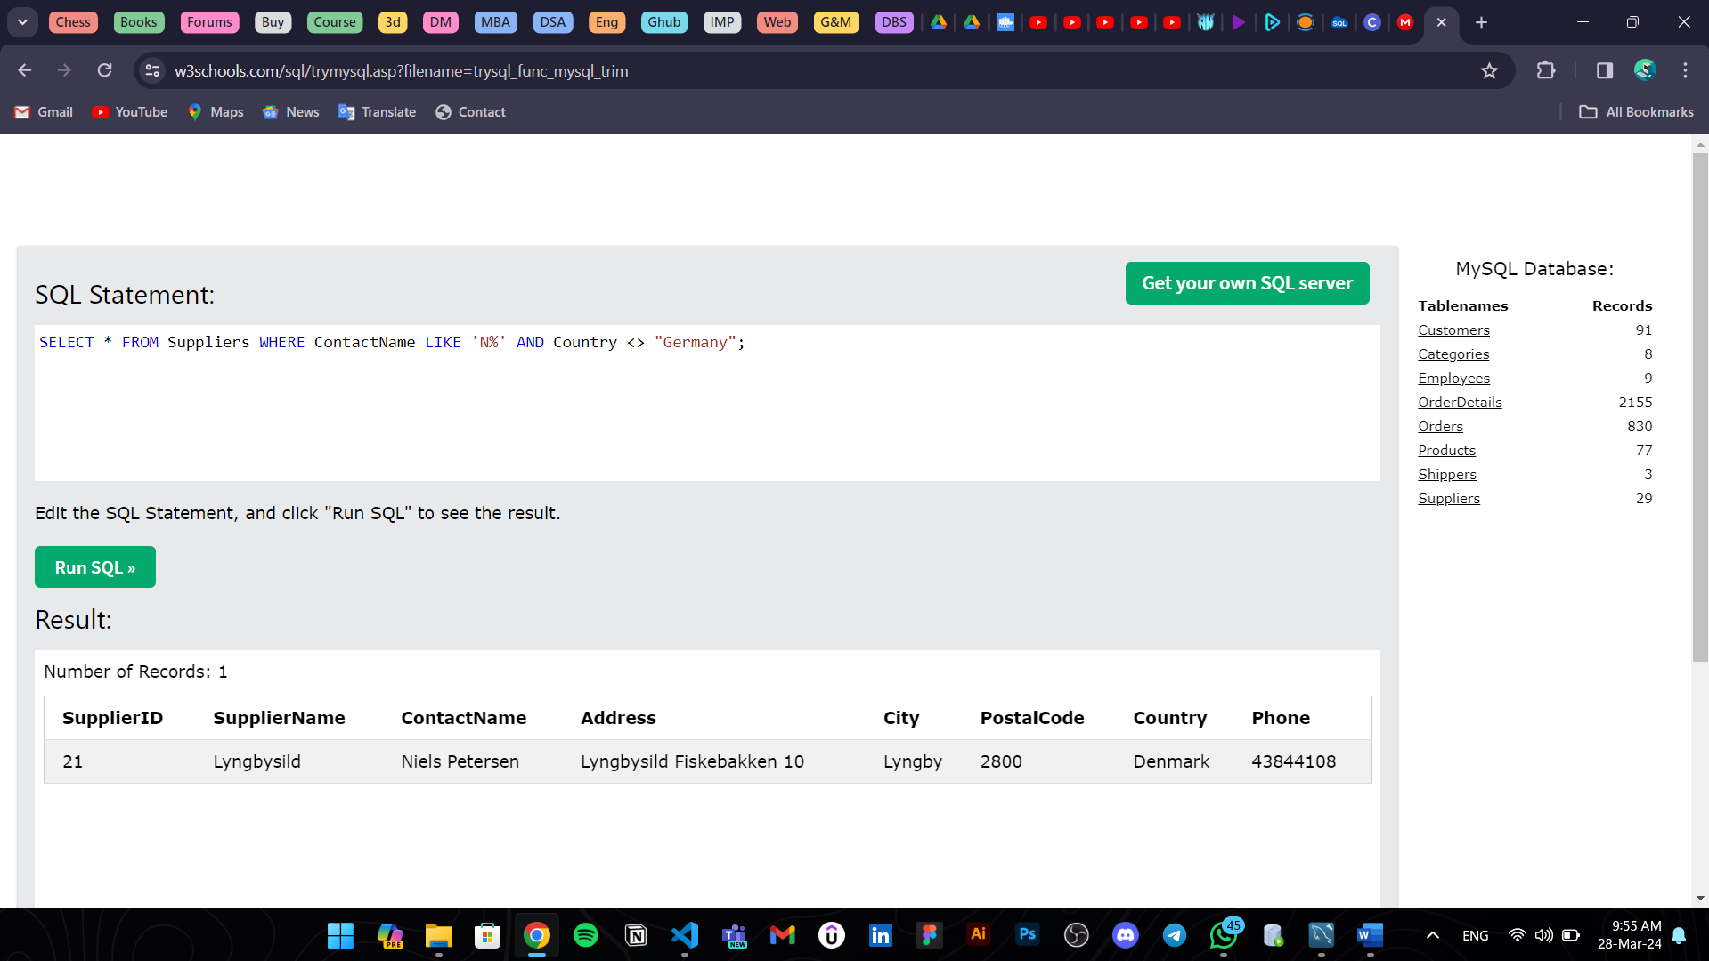

9. Retrieve Customers From The UK

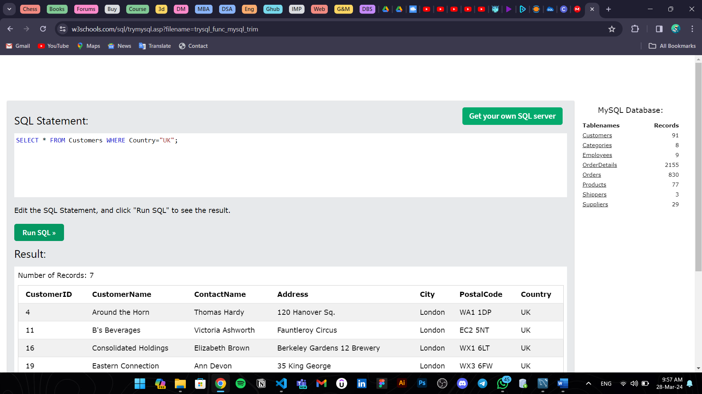

10. Retrieve Customers from Germany and Spain

